Auto Sector Mar 2024 Sales

 | Maruti Suzuki  Total Sales: 1,87,196 units, 10.06% YoY UP  Domestic Sales: 1,61,304 units, 15.25% YoY UP  PV Sales: 1,52,718 units, 15.03% YoY UP  Exports: 25,892 units, -14.03 % YoY DOWN
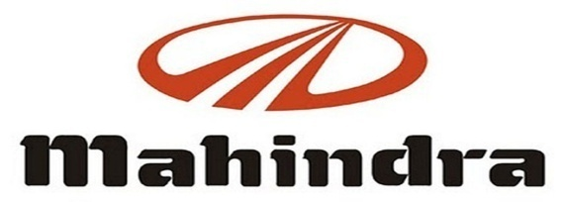 | Mahindra & Mahindra  Total Sales: 68,413 units, 4.00 % YoY UP  PV Sales: 40,631 units, 13.00% YoY UP  M&HCV Sales: 3317 units, 126.00% YoY UP  Exports: 1,573 units, -26% YoY DOWN
 | Bajaj Auto  Total Sales: 3,65,904 units, 25% YoY UP  Domestic Sales: 2,20,393 units, 18% YoY UP  CV Sales: 52,019 units, 17 % YoY UP  Exports: 1,45,511 units, 39 % YoY UP
 | Hero MotoCorp  Total Sales: 4,90,415 units, -5.56% YoY DOWN  Motorcycle Sales: 4,56,724 units, -6.02 YoY DOWN  Scooters Sales: 33,691 units, 0.73% YoY UP  Domestic Sales: 4,56,724 units, -6.00% YoY DOWN  Exports: 31,158 units, 87.56% YoY UP
 | TVS Motor  Total Sales: 3,54,592 units, 12.00% YoY UP  Domestic Sales: 2,60,532 units, 8.00% YoY UP  Exports: 91,972 units, 23.00% YoY UP
 | Atul Auto  Total Sales: 3,128 units, -0.82%  YoY DOWN
 | Escorts  Total Sales: 8,587 units, -16.70% YoY DOWN  Domestic Sales: 8,054 units, -16.1% YoY DOWN  Exports: 553 units, -24.3% YoY DOWN
 | Ashok Leyland  Total Sales: 22,866 units, -4.00% YoY DOWN  M&HCV Sales: 15,562 units, -7.00% YoY DOWN  LCV Sales: 7,304 units, 2.00% YoY UP
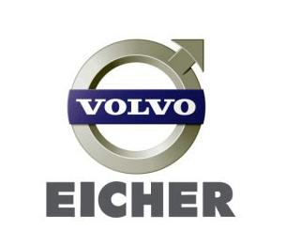 | Volvo-Eicher Commercial Vehicles  Total Sales: 11,242 units, -5.6% YoY DOWN  Exports: 461 units, 11.4% YoY UP  Eicher Motorcycle  Total Sales: 75,551 units, 5.00% YoY UP  Exports: 9,507 units, -23.00 % YoY DOWN
 | Tata Motors  Total Sales: 90,822 units, 2.00% YoY UP  CV Sales: 42,262 units, -10.00 YoY DOWN  PV Sales: 50,297 units, 14.00% YoY UP

