**01.04.24**

#### DMART=4525

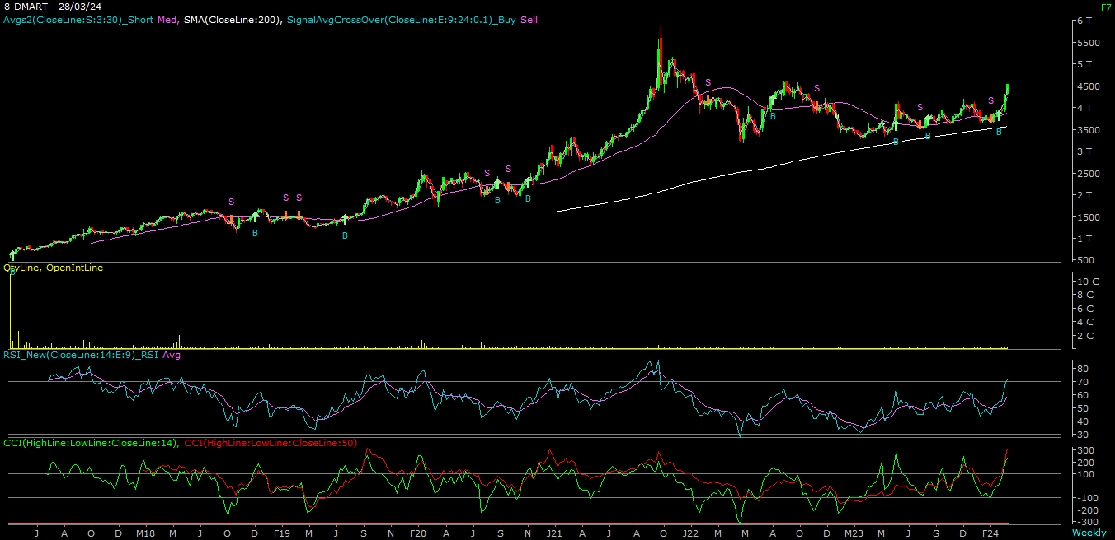

**ABOUT THE COMPANY**

Avenue Supermarts Limited (DMart) is a national supermarket chain, with a focus on value-retailing. They offer a wide range of products with a focus on the Foods, Non-Foods (FMCG) and General Merchandise & Apparel product categories.

**TECHNICAL VIEW**

**DMART LTD | CMP= ₹ 4525 | Stop loss ₹ 4350 | Tgt1: ₹ 4850 | Tgt2: ₹ 4950**

On the daily chart, we are observing a long consolidation breakout. On the weekly chart, we are observing a “Rounding Bottom” formation & trading above 200 SMA. Further, momentum indicator viz. MACD is positively poised. Combining the above parameters, it is evident that momentum on the upside is likely to continue. Hence, one can Buy the stock at CMP =₹ **4525 with** a stop loss of ₹**4350 for** atarget ₹ **4850 –** ₹ **4950 levels** in the mid-term.