**Nifty Technical Outlook (April - 2024) CMP = 22462**

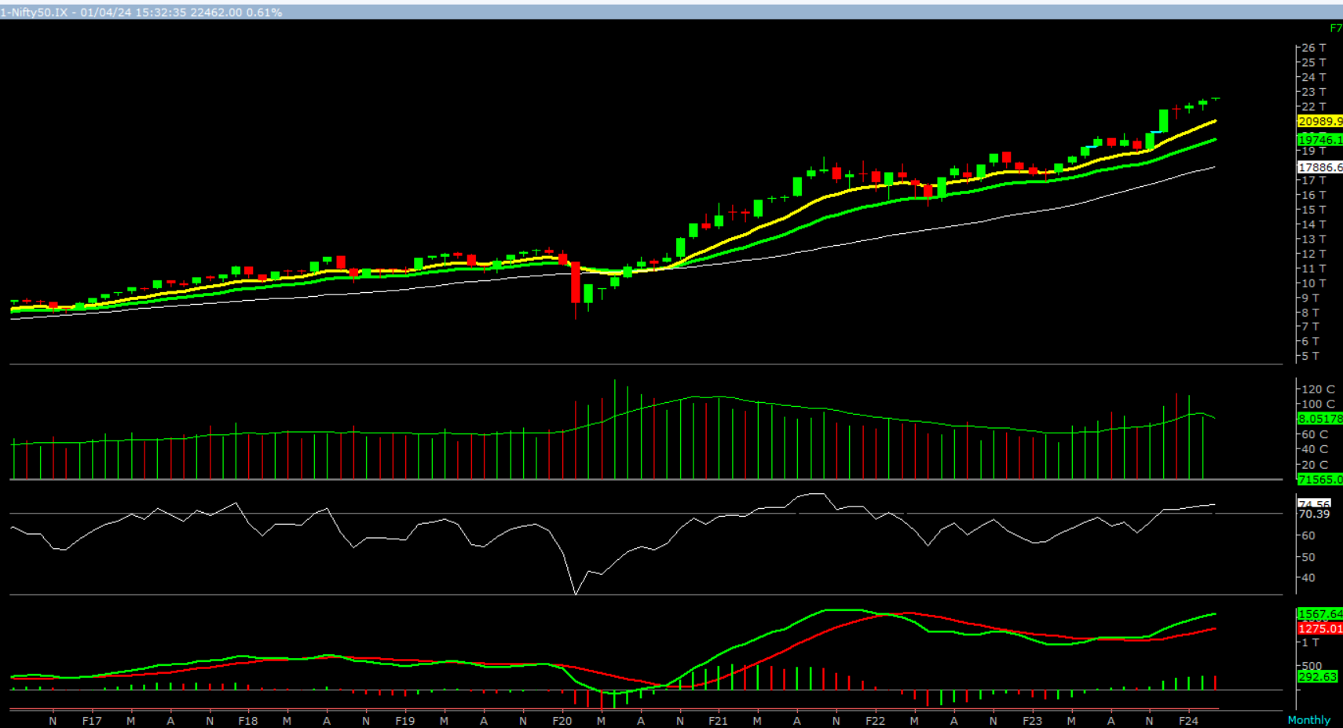

On the monthly chart, we are observing four consecutive narrow range formation with higher high formation. This suggests that markets are cautiously positive at current level. In coming month if Nifty trades and close above 22489 level then it is likely to test 22727 – 22966 - 23243 levels. However, if Nifty trades and close below 22162 level then it can test 21924 – 21686 - 21409 levels.

**Broadly, we are of the opinion that the monthly trend remains up. Hence, buy on decline strategy should be adopted. Any correction up to 22162 – 21924 levels should be used to long for a target of 22727 – 22966 - 23243** **levels.**