Auto Sector Feb 2024 Sales

 | Maruti Suzuki  Total Sales: 1,97,471 units, 14.59% YoY UP  Domestic Sales: 1,68,544 units, 8.65 YoY UP  PV Sales: 1,60,271 units, 8.68% YoY UP  Exports: 28,927 units, 68.11 % YoY UP
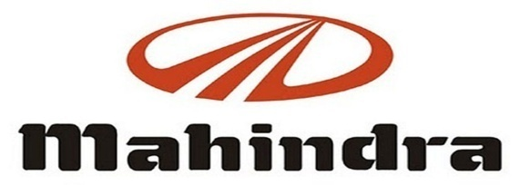 | Mahindra & Mahindra  Total Sales: 72,923 units, 24.00 % YoY UP  PV Sales: 42,401 units, 40.00% YoY UP  M&HCV Sales: 2900 units, 167.00% YoY UP  Exports: 1,539 units, -32% YoY DOWN
 | Bajaj Auto  Total Sales: 3,46,662 units, 24% YoY UP  Domestic Sales: 2,06,894 units, 35% YoY UP  CV Sales: 51,978 units, 16 % YoY UP  Exports: 1,39,768 units, 10 % YoY UP
 | Hero MotoCorp  Total Sales: 4,68,410 units, 18.74% YoY UP  Motorcycle Sales: 4,36,929 units, 17.50 YoY UP  Scooters Sales: 31,481 units, 39.25% YoY UP  Domestic Sales: 4,45,257 units, 16.46% YoY UP  Exports: 23,153 units, 90.66% YoY UP
 | TVS Motor  Total Sales: 3,68,424 units, 33.00% YoY UP  Domestic Sales: 2,67,502 units, 21.00% YoY UP  Exports: 98,856 units, 85.00% YoY UP
 | Atul Auto  Total Sales: 2,300 units, 8.24%  YoY UP
 | Escorts  Total Sales: 6,481 units, -17.00% YoY DOWN  Domestic Sales: 6,041 units, -16.6% YoY DOWN  Exports: 440 units, -22.3% YoY DOWN
 | Ashok Leyland  Total Sales: 17,464 units, -6.00% YoY DOWN  M&HCV Sales: 11,369 units, -10.00% YoY DOWN  LCV Sales: 6,095 units, 3.00% YoY UP
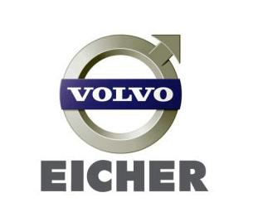 | Volvo-Eicher Commercial Vehicles  Total Sales: 7,424 units, 1.9% YoY UP  Exports: 316 units, 5.0% YoY UP  Eicher Motorcycle  Total Sales: 75,935 units, 6.00% YoY UP  Exports: 8,013 units, 13.00 % YoY UP
 | Tata Motors  Total Sales: 86,406 units, 10.76% YoY UP  CV Sales: 35,085 units, -4.00 YoY DOWN  PV Sales: 51,321 units, 19.00% YoY UP  Exports: 1572 units, -7.47 % YoY DOWN

