**Nifty Technical Outlook (MARCH - 2024) CMP = 22982**

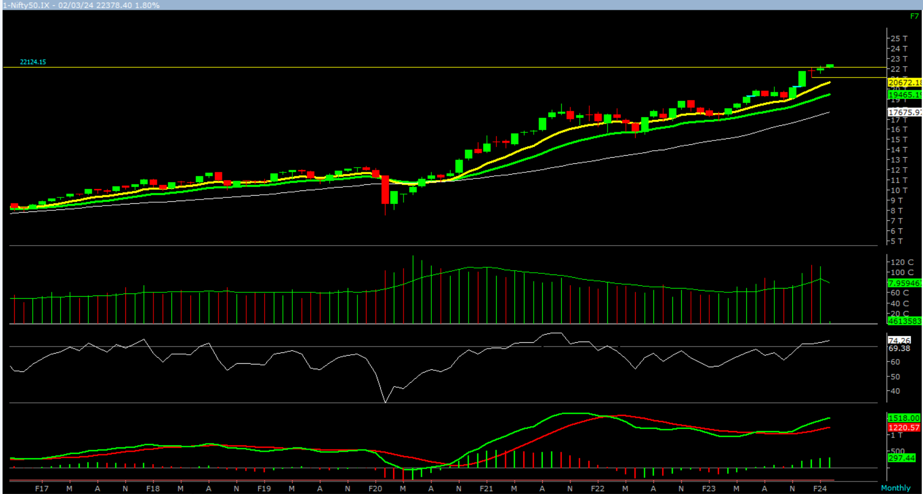

On the monthly chart, we are observing three consecutive narrow range formation with higher high formation. This suggests that markets are cautiously positive at current level. In coming month if Nifty trades and close above 22136 level then it is likely to test 22360 – 22584 - 22845 levels. However, if Nifty trades and close below 21827 level then it can test 21604 – 21340 – 21119 levels.

**Broadly, we are of the opinion that the monthly trend remains up. Hence, buy on decline strategy should be adopted. Any correction up to 21827 - – 21604 levels should be used to long for a target of 22360 – 22584 - 22845** **levels.**