**04.03.24**

#### TATASTEEL=151

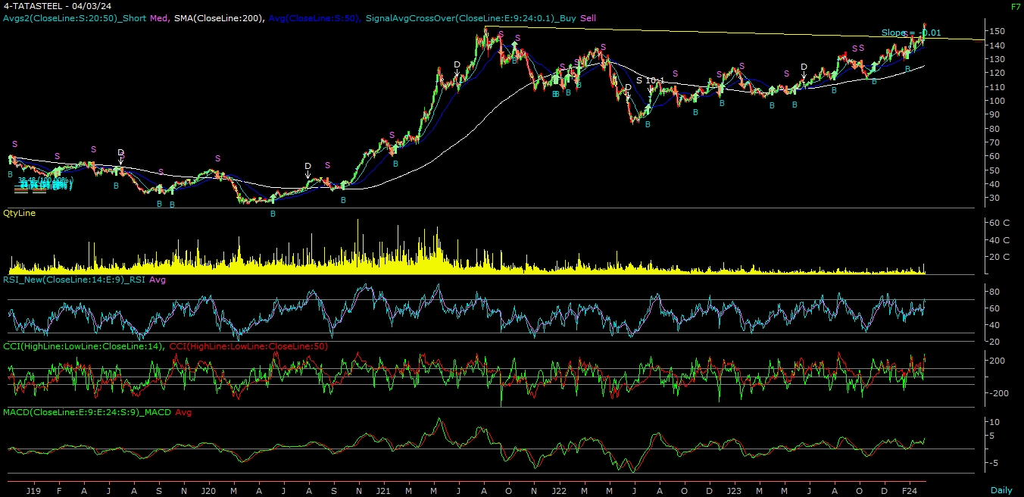

**ABOUT THE COMPANY**

Tata Steel Ltd is Asia's first integrated private steel company setup in 1907.  
The company has presence across the entire value chain of steel manufacturing from mining and processing iron ore and coal to producing and distributing finished products.

The company’s product mix includes flat products such as hot rolled coils, cold rolled coils and galvanised steel, and long products such as wire rods, rebar, ferro alloys, tubes, bearings and wires. The product segments cater to agriculture, automotive, construction, consumer goods, energy and power, engineering and material handling etc.

**TECHNICAL VIEW**

**TATASTEEL LTD | CMP= ₹ 151 | Stop loss ₹ 120 | Tgt1: ₹ 230 | Tgt2: ₹ 250**

On the daily chart, we are observing long consolidation breakout & trend line breakout. On the weekly chart stock making a “Higher high” formation. Further, momentum indicator viz. MACD is positively poised and even the stock is outperforming the benchmark indices. Combining the above parameters, it is evident that momentum on the upside is likely to continue. Hence, one can buy the stock at CMP = **151 with** a stop loss of ₹**120 for** atarget ₹ **230 –** ₹ **250 levels** in a couple of weeks.