Auto Sector July-2023 Sales

 | Maruti Suzuki  Total Sales: 1,81,630 units, 3.24% YoY UP  Domestic Sales: 1,59,431 units, 2.45% YoY UP  PV Sales: 1,52,126 units, 6.49% YoY UP  Exports: 22,199 units, 9.29% YoY UP
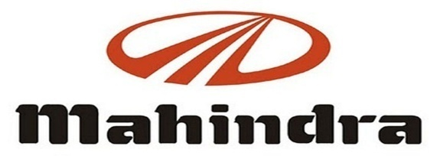 | Mahindra & Mahindra  Total Sales: 66,124 units, 18.00 % YoY UP  PV Sales: 36,205 units, 29.00% YoY UP  M&HCV Sales: 995 units, 23.00% YoY UP  Exports: 2,540 units, -9% YoY DOWN
 | Bajaj Auto  Total Sales: 3,19,747 units, -10% YoY DOWN  Domestic Sales: 1,79,263 units, -2% YoY DOWN  CV Sales: 37,273 units, 101 % YoY UP  Exports: 1,40,484 units, -18 % YoY down
 | Hero MotoCorp  Total Sales: 3,91,310 units, -12.17% YoY DOWN  Motorcycle Sales: 3,60,592 units, -14.40% YoY Down  Scooters Sales: 30,718 units, 26.45% YoY UP  Domestic Sales: 3,71,204 units, -13.81% YoY DOWN  Exports: 20,106 units, 34.97% YoY UP
 | TVS Motor  Total Sales: 3,25,977 units, 4.00% YoY UP  Domestic Sales: 2,35,230 units, 17% YoY UP  Exports: 89,213 units, -20.36% YoY DOWN
 | Atul Auto  Total Sales: 2,110 units, 11.05%  YoY UP
 | Escorts  Total Sales: 5,570 units, 3.90% YoY UP  Domestic Sales: 5,161 units, 9.7% YoY UP  Exports: 409 units, -37.7% YoY DOWN
 | Ashok Leyland  Total Sales: 15,068 units, 11.00% YoY UP  M&HCV Sales: 9,571 units,17.00% YoY up  LCV Sales: 5,497 units, 0.36% YoY UP
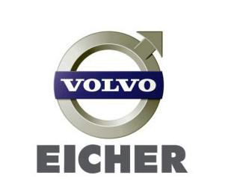 | Volvo-Eicher Commercial Vehicles  Total Sales: 5,877 units, -1.8 YoY DOWN  Exports: 425 units, -15.2% YoY DOWN  Eicher Motorcycle  Total Sales: 73,117 units, 32.00% YoY UP  Exports: 7,055 units, -22.00 % YoY DOWN
 | Tata Motors  Total Sales: 80,633 units, -1.41% YoY DOWN  Exports: 1,789 units, -36.37% YoY DOWN  CV Sales: 32,944 units, -4.0 YoY DOWN  PV Sales: 47,689 units, 0.11% YoY UP

