**Nifty Technical Outlook (AUG - 2023) CMP = 19753**

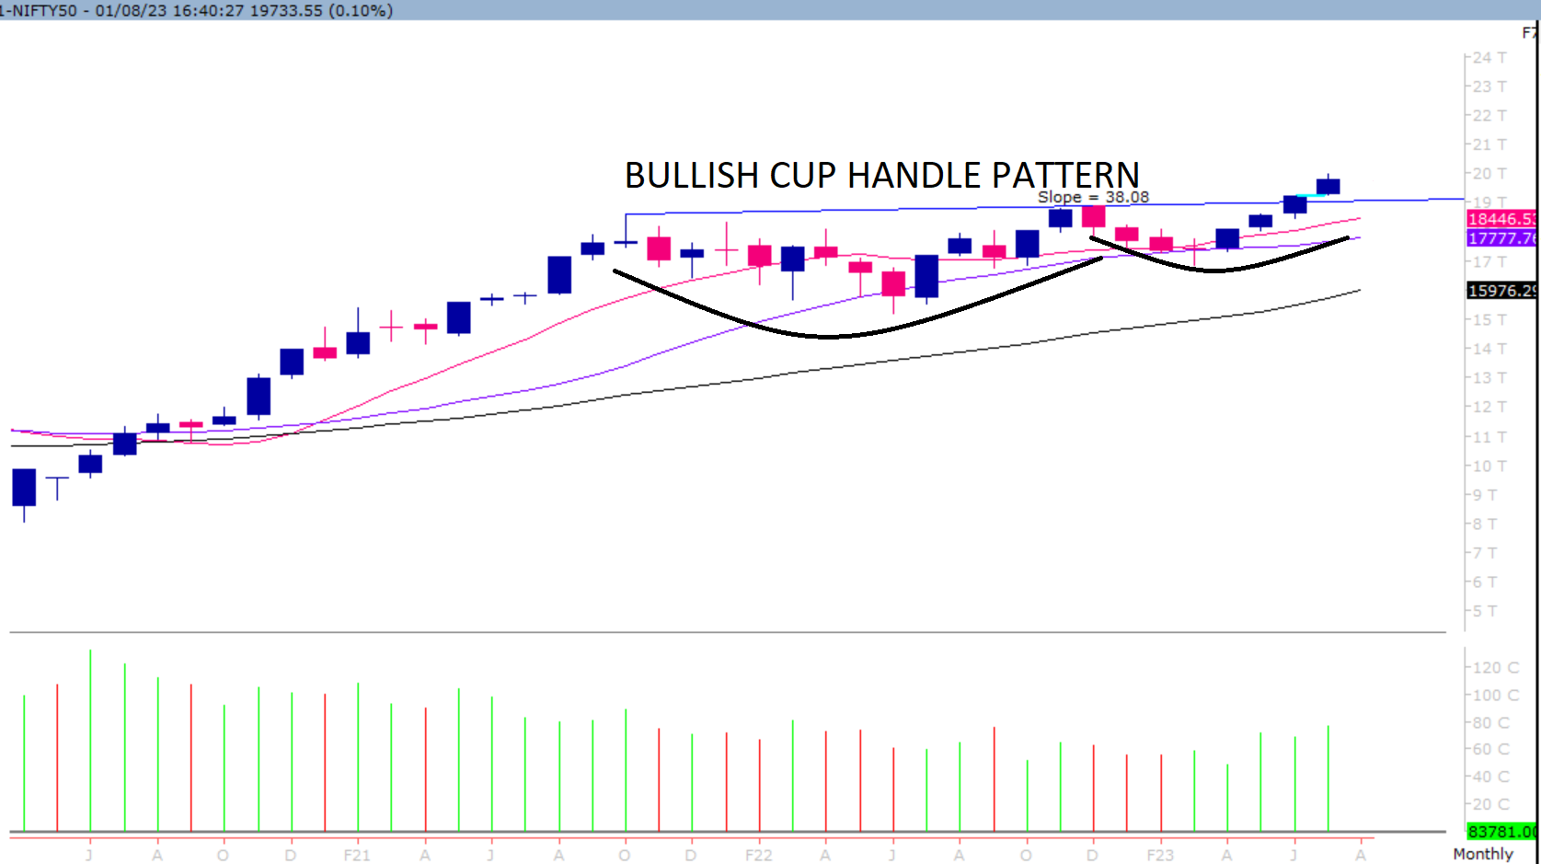

On the monthly chart, we are observing that prices have close well above the bullish Cup- Handle pattern. This suggests that the momentum on the upside is likely to continue. In coming month if Nifty trades and close above 19904 level then it is likely to test 20125 – 20346 - 20603 levels. However, if Nifty trades and close below 19602 level then it can test 19381 – 19160 - 18903 levels.

**Broadly, looking at the current price action it is evident that Nifty is likely to test 20125 – 20346 - 20603.**

**Hence, one needs to adopt positive approach at current level as stock specific activity is likely to continue.**